Resources: Label 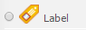
A label can be used to add text, images, and multimedia. It will help to improve the appearance of your course and can be added anywhere on your course home page. It is also useful to organize content for your learners. For example, you may use labels to identify assignments, readings, and quizzes. You may also have labels that identify topical sections within a module.

Contents
- Add a Label
- Edit Settings
- Delete a Label

Add a Label
- Go to the course home page.
- Click on the Turn editing on button at the top right of the page.
- Click Add an activity or resource.

- Click on the radio button next to the Label and click on the Add button.
The "Adding a new Label" page will appear.
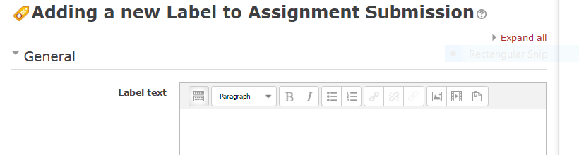
multimedia
text

pictures
text

text
text

- Typically, it will be text you will want to add. Type text in the text window. If you need to add a picture or multimedia, select those icons and follow the prompts.
- Click on the Save and return to course button.

Edit Settings
- Go to the course home page.
- Click on the Turn editing on button.
- Click Edit next to the Label resource.
- Click Edit settings. You may adjust the size or colour of your font, you may add a picture or adjust the picture’s size or position.
- Click Save and return to course.

Delete a Label
- Go to the course home page.
- Click on the Turn editing on button.
- Click Edit next to the Label resource.
- Click Delete.

Notes:
For additional information, see the Using Labels Moodle Docs or contact Moodle Help.

